**Step 1: Setup Git Repository**

**Description:**  
Navigated to the existing GitDemo repository and verified that the master branch is tracking origin/main.

**Commands Used:**

cd ~/GitDemo

git status

git branch -a

git pull origin main

**Step 2: Create a New Branch**

**Description:**  
Created a new branch named Git-T03-HOL-002 and switched to it.

**Commands Used:**

git checkout -b Git-T03-HOL-002

**Screenshot(s):**  
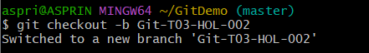

**Step 3: Add Files in the Branch**

**Description:**  
Created a new file labfile.txt, added some content, staged it, and committed it.

**Commands Used:**

echo "Lab changes" > labfile.txt

git add labfile.txt

git commit -m "Added labfile.txt for HOL_002"

git status

**Screenshot(s):**  
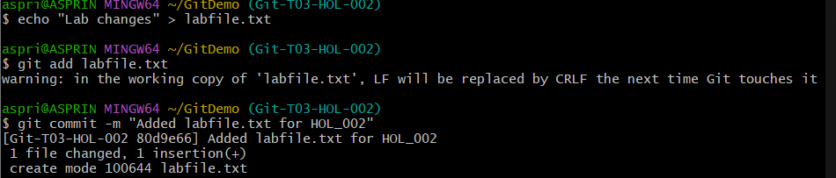

**Step 4: Push Branch to Remote**

**Description:**  
Pushed the newly created branch Git-T03-HOL-002 to the remote repository and set it to track the remote branch.

**Commands Used:**

git push -u origin HEAD

**Screenshot(s):**  
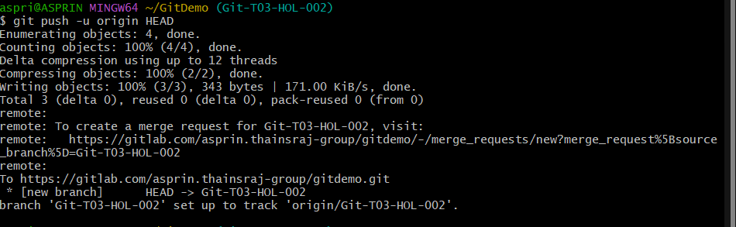

**Step 5: Verify on Remote**

**Description:**  
Checked the repository on GitLab and confirmed that the branch Git-T03-HOL-002 exists and contains labfile.txt.

**Commands Used:**

git branch -a

**Screenshot(s):**

